|  |
| --- |
| Circle Language Spec: Execution Control |

## Else If in a Diagram

The concept of the Else If statement is already covered in the article *Else If*. This article only explains its expression in a diagram.

Below is an example of the diagrammatic expression of an Else If statement.

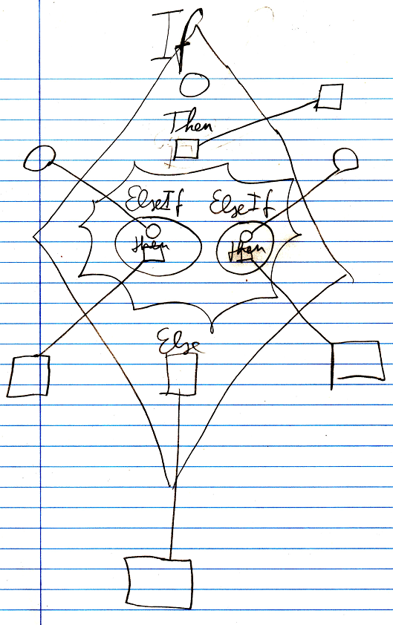

The diamond is the Else If command. the top circle inside the diamond is the condition of the first If. If the condition returns True, then the Then clause is executed. In the middle of the diamond there is a nonagon. Inside the nonagon any number of Else If’s can be specified. An Else If object also has a condition and a Then clause. If the condition returns True then the Then clause is executed. If the condition is False, then the next Else If’s condition is evaluated. If none of the Else If’s conditions return True, then the Else clause is executed, which is visible at the bottom of the diamond. The Else clause is optional. If the Else clause is not used, it can be left out of the diagram.

The conditions and the clauses can all be references to something defined outside the diamond. The conditions and the clauses can also be filled in right inside the diamond.

The *definition* of the Else If command is part of a system module of execution control commands. The public elements of the definition look like this:

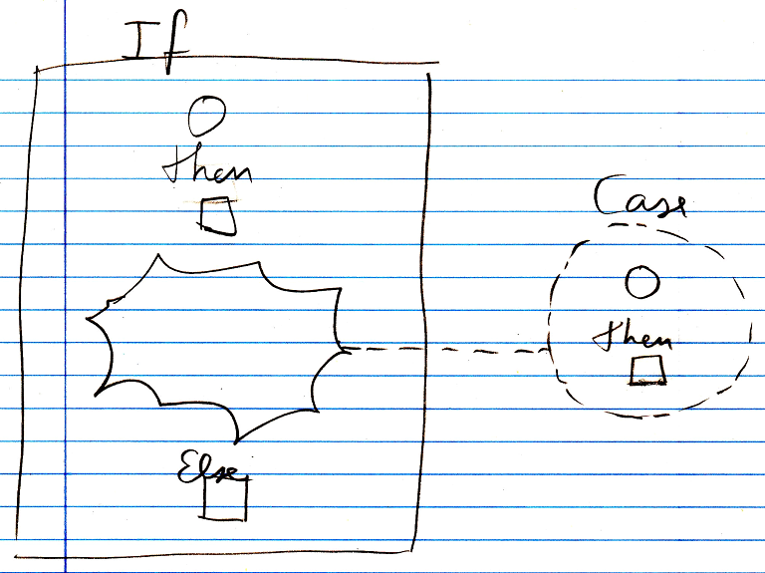

Nothing is filled in yet for the condition, the Then clause or the Else clause, and there are no Cases defined yet. But a *class* for a Case *is* defined. The Case class defines a condition and a Then clause.

There is another, separate definition of the Else If command, that is the same as the other Else If command definition, except that it does not have an Else clause in it.